**DAILY ONLINE ACTIVITIES SUMMARY**

|  |  |  |  |  |  |  |  |  |
| --- | --- | --- | --- | --- | --- | --- | --- | --- |
| **Date:** | **14/07/2020** | | | | | **Name:** | **VIRESH** | |
| **Sem & Sec** | **4th SEM & ‘B’ SEC.** | | | | | **USN:** | **4AL18CS097** | |
| **Online Test Summary** | | | | | | | | |
| **Subject** | | **---** | | | | | | |
| **Max. Marks** | | **30** | | **Score** | | | **--** | |
| **Certification Course Summary** | | | | | | | | |
| **Course** | **Introduction to Digital Marketing.** | | | | | | | |
| **Certificate Provider** | | | **Greatlearning Academy** | | **Duration** | | | **2.5 Hrs.** |
| **Coding Challenges** | | | | | | | | |
| **Problem Statement 1:** **Write a java program to check for balanced parenthesis** | | | | | | | | |
| **Status: Executed** | | | | | | | | |
| **Uploaded the report in Github** | | | | | **Yes** | | | |
| **If yes Repository name** | | | | | **alvas-education-foundation/Viresh** | | | |
| **Uploaded the report in slack** | | | | | **Yes** | | | |

**Online Test Summary:** **No internals conducted today.**

**Online Certification Course Summary: Today I have gone through Purpose of using Facebook as Marketing Channel and Facebook Interface and Types of Audiences.**

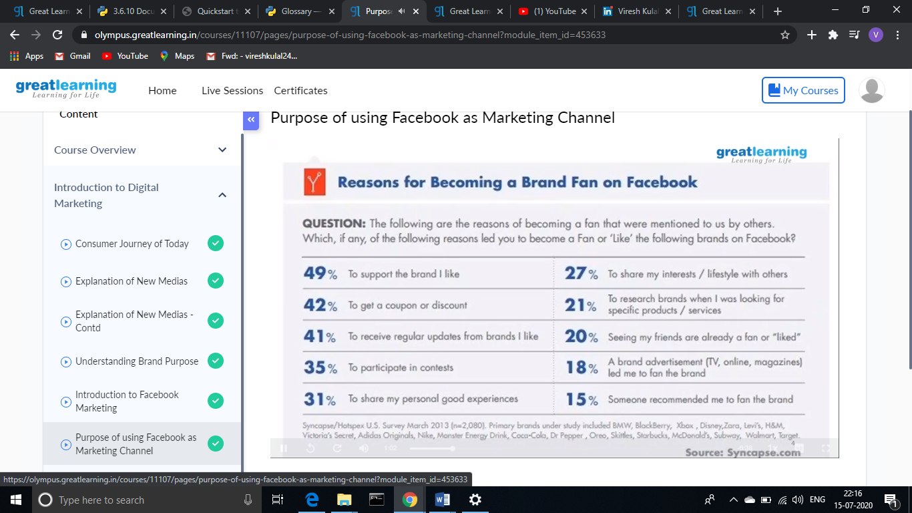

**This is the snapshot of today’s session.**

**Online Coding Summary: Today I had received one program from prof. Shilpa CSE Dept. The program is mentioned above. I have also uploaded it to my Github repository.**

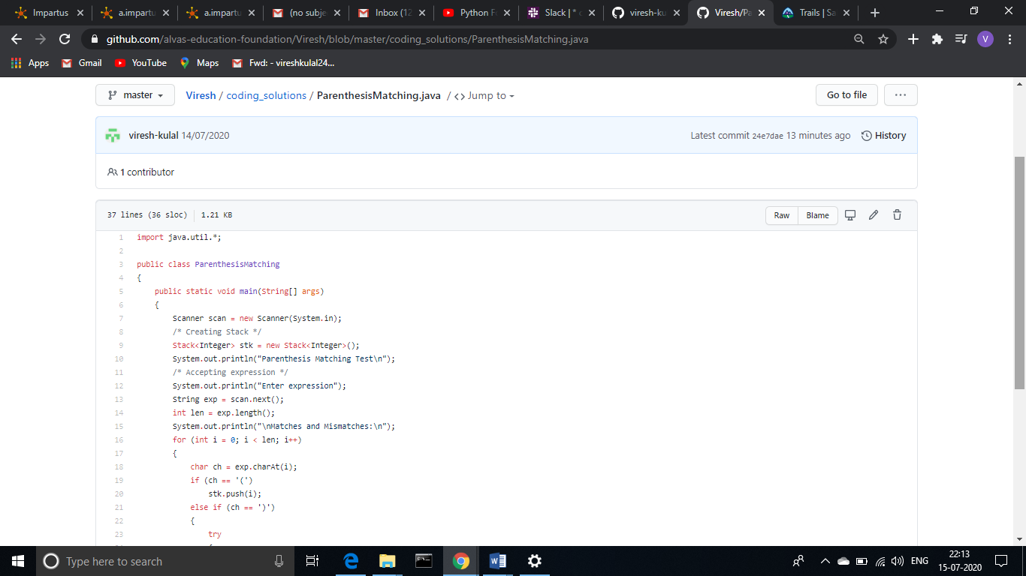

## This is the Snapshot of my Github repository were I have uploaded the code. File name is ParenthesisMatching.java

**Thank You.**